Sharing of Joys and Concerns
The Lord’s Prayer

Our Father, who art in heaven, hallowed be thy name. Thy kingdom come, Thy will be done on earth as it is in heaven. Give us this day our daily bread and forgive us our trespasses, as we forgive those who trespass against us. And lead us not into temptation, but deliver us from evil. For thine is the kingdom, and the power, and the glory, forever. Amen.
*Singing Our Faith #114 (vs. 1 & 3) “Many Gifts, One Spirit”
*Blessing and Dismissal
*Postlude

Scatter to Serve God & Neighbor

Welcome to all! We gather to praise God for the innumerable blessings given to us and to grow deeper in the Spirit. Joyfully, let us lift our hearts to God.

DIRECTORY OF CHESTNUT HILL UNITED METHODIST CHURCH
Adam J. White | Minister
Sharon Mayhew | Director of Music
Monica Campbell | Administrative Assistant
Judy Martin | Bookkeeper
Judy Robertson  Elizabeth Nichols | Lay Leader  Missionary in Henry County


C hestnut Hill
United Methodist Church

Making disciples of Jesus Christ
for the transformation of the world.
You are welcome at Chestnut Hill UMC.

4660 Fort Avenue ~ Lynchburg, Virginia 24502
Church: 434-239-8423
Minister’s Cell: 434-944-7723, Minister’s Email: awhite@ves.org
Email: chestnuthillumc@comcast.net
On the Web at chestnuthillumc.net
Find us on Facebook: Chestnut Hill United Methodist Church

Chestnut Hill United Methodist Church

10:30 a.m. ~ August 30, 2026 ~ Fourteenth Sunday after Pentecost
Our ministry vision for the Virginia Annual Conference is “to be
disciples of Jesus Christ who are lifelong learners, who influence others to serve.”

Welcome! Join us in worshiping God!
Prelude
Welcome and Ministry Announcements
Welcome in the name of Christ our Lord. Please register your attendance, printing your name, address, phone, and email, on the attendance pad provided on your pew. Thank you for silencing cell phones as we gather to worship God.
Invocation
*Greeting
In the floods of tribulation,
While the billows o'er me roll,
Jesus whispers consolation,
And supports my fainting soul,
Hallelujah, hallelujah,
hallelujah, praise the Lord.
In the sacred page recorded;
Thus the word securely stands,
Fear not, I'm in trouble near thee,
Nought shall pluck thee from my hands.
Hallelujah, hallelujah,
hallelujah, praise the Lord.
All I meet I find assist me,
In my path to heavenly joy;
Where the trials now attend me,
Trials never more annoy.
Hallelujah, hallelujah,
hallelujah, praise the Lord.

*Singing Our Faith #170 “O How I Love Jesus”

Opening Prayer
Grant us, O Lord, to trust in you with all our hearts; for, as you always resist the proud who confide in their own strength, so you never forsake those who make their boast of your mercy; through Jesus Christ our Lord, who lives and reigns with you and the Holy Spirit, one God, now and for ever. Amen.

Special Music “I Saw the Light” by H. Williams

Greeting Friends and Neighbors

Prayer of Illumination
Living God, as we turn to your holy word today, send your Holy Spirit to clear away our distracting thoughts and quiet our busy minds. Open our ears to hear your truth, soften our hearts to receive your grace, and transform us by your wisdom, that we may live as faithful followers of Christ. Amen.
Scripture Lessons:
Jeremiah 15:15-21, Romans 12:9-21, and Matthew 16:21-28
The Word of God for the people of God.

Thanks be to God.
Singing Our Faith #349 “Turn Your Eyes upon Jesus”
The Good News “It’s Not Easy Being Green”
Bringing Forward God’s Tithes and Our Gifts
*Doxology #95 Praise God from whom all blessings flow; praise him, all Creatures here below; praise him above, ye heavenly host; praise Father, Son, and Holy Ghost. Amen.
*Prayer of Thanksgiving

**Calendar **
Friday, 9/4 |  | Church Office Closed
 | 9:30 a.m. | Homeschool
** Looking Ahead on the Calendar **
Monday, 9/7 |  | Labor Day ~ Church Office Closed
For the Grocery Cart:
August ~ All Canned Goods (with or without Pop-tops.)

Birthdays: August 31-Fred Norvelle.
September 4-Adna Fainter. 5-Shirley Johnson.
8-Monica Campbell. 9-Mintcy Maxham.
12-Clarissa Clarke.

LOST…

A “snake” bracelet (wrap around) with a setting of two (2) stones. It belongs to Kathleen Baker. If found see Maggie Musgrove.

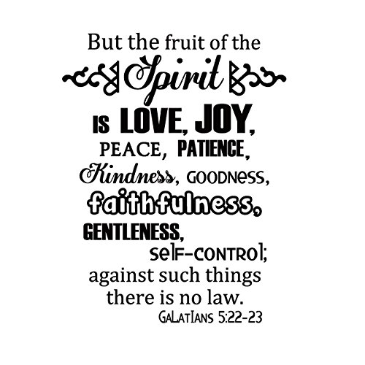

**Calendar **
Friday, 9/4 |  | Church Office Closed
 | 9:30 a.m. | Homeschool
** Looking Ahead on the Calendar **
Monday, 9/7 |  | Labor Day ~ Church Office Closed
For the Grocery Cart:
August ~ All Canned Goods (with or without Pop-tops.)
Birthdays: August 31-Fred Norvelle.
September 4-Adna Fainter. 5-Shirley Johnson.
8-Monica Campbell. 9-Mintcy Maxham.
12-Clarissa Clarke.

LOST…

A “snake” bracelet (wrap around) with a setting of two (2) stones. It belongs to Kathleen Baker. If found see Maggie Musgrove.

